Guidelines:
- Create separate functions for every operation.
- In event handlers or cases where a function is required as an argument, Define a separate function and pass it instead of using an arrow function as an argument.
- Handle errors in your code.
- Check if the user input is valid before processing it.
- Naming the folders of your solutions in git follows the following format: Task#
- If some tasks require you to complete the work of the previous task, do not create a new folder.
- Documentation for react native styles and a tool to try different styles : Style · React Native

Html/ JS tasks

1. Create a github account, Create a github repo called JoVision Javascript tasks and push it to your account[Git, Repo creation]

Resources:
https://dev.to/chefgs/git-101-how-to-create-your-first-github-repository-4no9

2. Create an HTML page that only has a button called "Click me", When clicked it should print "Hello World" in the console[Javascript, EventsHandleing]

Resources:
https://www.freecodecamp.org/news/html-button-onclick-javascript-click-event-tutorial/

3. Push the page to github in a separate folder named the task's number, From now on do the same for every task you complete [Git, Commit and push code to git]

Resources:
https://dev.to/chefgs/git-101-how-to-create-your-first-github-repository-4no9

4. Create an HTML page that only has a button called "Click me", When clicked it should create an array of all the numbers between 0, 100 and print their sum[Javascript, Array creation, Looping]

Resources:
https://www.w3schools.com/js/js_arrays.asp
https://www.w3schools.com/js/js_loop_for.asp

5. Create an HTML page that only has a button called "Click me", When clicked it should create an array of all the numbers between 0, 100 and print the sum of only the even numbers[Javascript, Looping, If statements, Filtering]

Resources:
https://www.w3schools.com/js/js_if_else.asp

6. Create an HTML page that has 5 buttons: [Javscript, Array methods]
A. Button one: When clicked it creates an array of all the numbers between 0 to 100, Removes the numbers that are divisible by 3 from the array and prints it in the console
B. Button two: When clicked it creates an array of all the numbers between 0 to 100, Adds the numbers from 100 to 150 to the array and prints them in the console
C. Button three: When clicked it creates an array of all the numbers between 0 to 100, Adds 3 to each array member and print it in the console
D. Button four: When clicked it creates an array of all the numbers between 0 to 100, Then prints the members from index 20 to 40 in the console
E. Button five: When clicked it should create an array of all the numbers between 0 to 100, Shuffle the members of the array using the function provided to you in the hints, prints the shuffled array in the console, sorts it in descending order and prints in again

Hints:
Function to shuffle an array:
function shuffleArray(array) {
for (let i = array.length - 1; i > 0; i--) {
let j = Math.floor(Math.random() * (i + 1));
[array[i], array[j]] = [array[j], array[i]];
}
}

Usage:
let arr = [1, 2, 3, 4, 5];
shuffleArray(arr);

Resources:
https://www.w3schools.com/js/js_array_methods.asp
https://www.w3schools.com/js/js_array_search.asp
https://www.w3schools.com/js/js_array_sort.asp
https://www.w3schools.com/js/js_array_iteration.asp

7. Create an HTML page that shows the current time in the format "HH:MM:SS", The time should update every second. [Javascript, Date and time, Intervals, Date formatting]

Resources:
https://www.w3schools.com/jsref/met_win_setinterval.asp
https://www.w3schools.com/jsref/jsref_obj_date.asp

8. In git create a new branch(In the same repo) called "Learning-Javascript-Requests" and from now, Push the tasks to this branch instead of your main/master branch[Git, Branches]

Resources:
https://docs.github.com/en/pull-requests/collaborating-with-pull-requests/proposing-changes-to-your-work-with-pull-requests/creating-and-deleting-branches-within-your-repository

9. Create an HTML page that has a button called "Get ip", When clicked it makes a request to "https://api.ipify.org/" and print the response in the console[Javascript, Requests]

Resources:
https://www.geeksforgeeks.org/javascript-fetch-method/

10. Create an HTML page that has a button called "Get ip", When clicked it makes a request to "https://api.ipify.org/" and replace the text of the button to the API's result[Javascript, Requests, DOM manipulation]

Resources:
https://www.w3schools.com/js/js_htmldom.asp

11. Create an HTML page that has a button called "Get ip", When clicked it makes a request to "https://api.ipify.org/" and replace the text of the button with the API's result, Handle errors in the request by creating a window alert of the error. [Javascript, Error handling, Window popups]
*Hint: To test your code, Create errors intentionally by editing the url of the request to an invalid one, For example: "https://api.ipify.orgx/"

Resources:
https://www.w3schools.com/js/js_errors.asp

12. Create an HTML page that has two text fields with the title and place holder of 'Name', and 'Age'. And a button called "Submit". When pressed it should create an object of the form :
{
"name": "the-name-you-entered",
"age" : "the-age-you-entered",
"timestamp" : "the-date-and-time-of-the-button-press"
}
Then create a window popup that says "Your name is: " followed by the name you entered in the text field, and "Your age is: " followed by the age you entered in the text field and the timestamp of the button press. Note that you have to fill in the window's popup from the object you created. [Javascript, Object creation, Object deconstruction]

Resources:
https://www.w3schools.com/js/js_object_definition.asp
https://developer.mozilla.org/en-US/docs/Web/JavaScript/Reference/Operators/Destructuring_assignment

13. Create an HTML page that has a text field with the title and placeholder of 'Name', And a button called "Submit".
When clicked it should make a request to https://api.agify.io and create a popup that says "Your name is: " followed by the name you entered in the text field, and "Your age is: " followed by the age that was received from the age request. [Javascript].
Note that you have to fill in the window's popup from the response you received from the request's response. [Javascript, Requests, Promises, Object deconstruction]
*Hint: the API expects the person's name to be in the URL's query parameters with the key "name"

Resources:
https://www.semrush.com/blog/url-parameters/
https://www.w3schools.com/js/js_promise.asp

14. Merge the "Learning-Javascript-Requests" branch with the main/master branch in git. [Git, Branch merging]
Resources:
https://www.w3schools.com/git/git_branch_merge.asp?remote=github
React Native Tasks

15. Install the react-native development environment using the provided guide. Use react-native-cli not Expo, Create a new repo called JoVision react native tasks and push your code to it from now on

Lookup this guide (To install React Native CLI):
https://reactnative.dev/docs/set-up-your-environment
Guidelines for React Native Tasks and GitHub Uploads

- You will only need one react native project for all the react native tasks.
- Create a folder named “Tasks” within your React Native project directory.
- Inside this folder, create components for each specific task. For example, you can name the component for the first task “Task16” and place it in a file named “Task16.js.”
- Next, render the tasks you’re working on (as components) in your app.tsx file.
- You can choose the code editor of your choice.

Visual representation of the React Native Project and Component Integration:
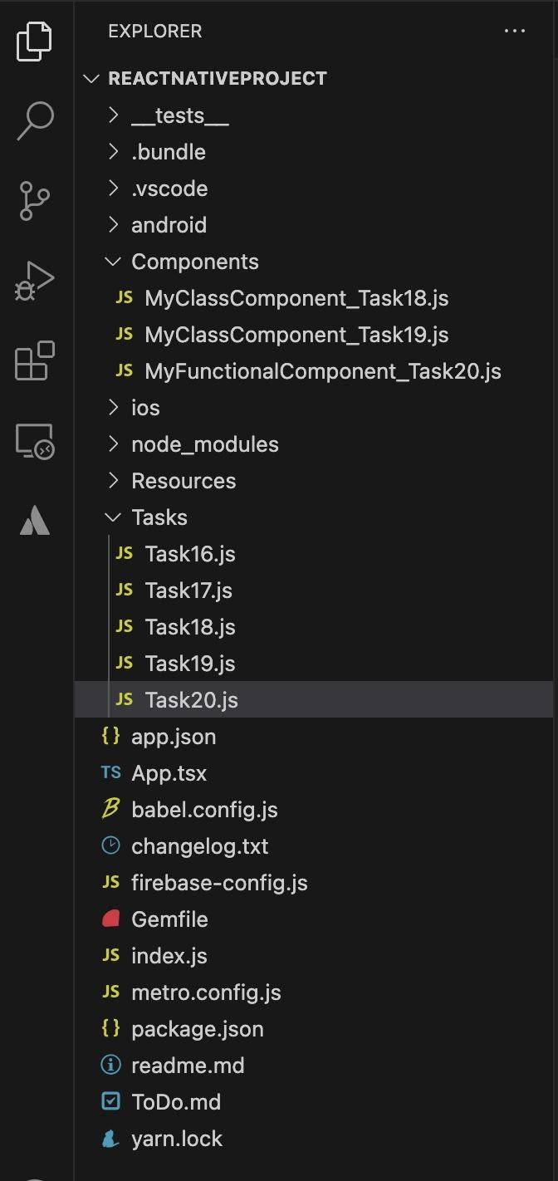
- React Native Project Structure:

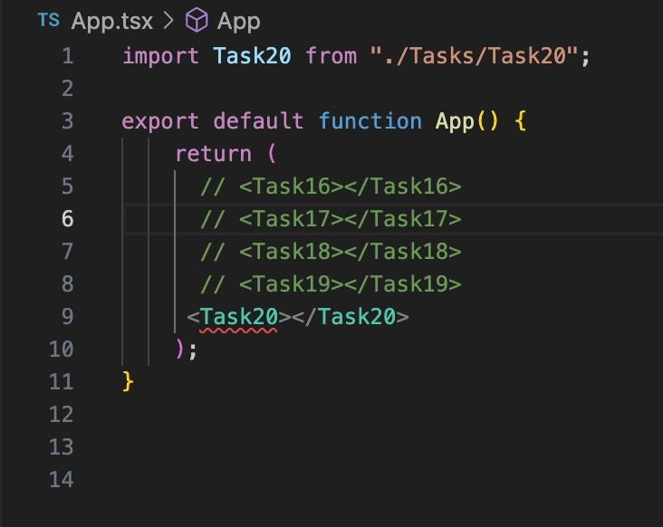
- Your main Render (App.tsx File):

Tasks can be rendered as individual components in App.tsx.

Instead of writing your code in the App.tsx file, write it in a separate file

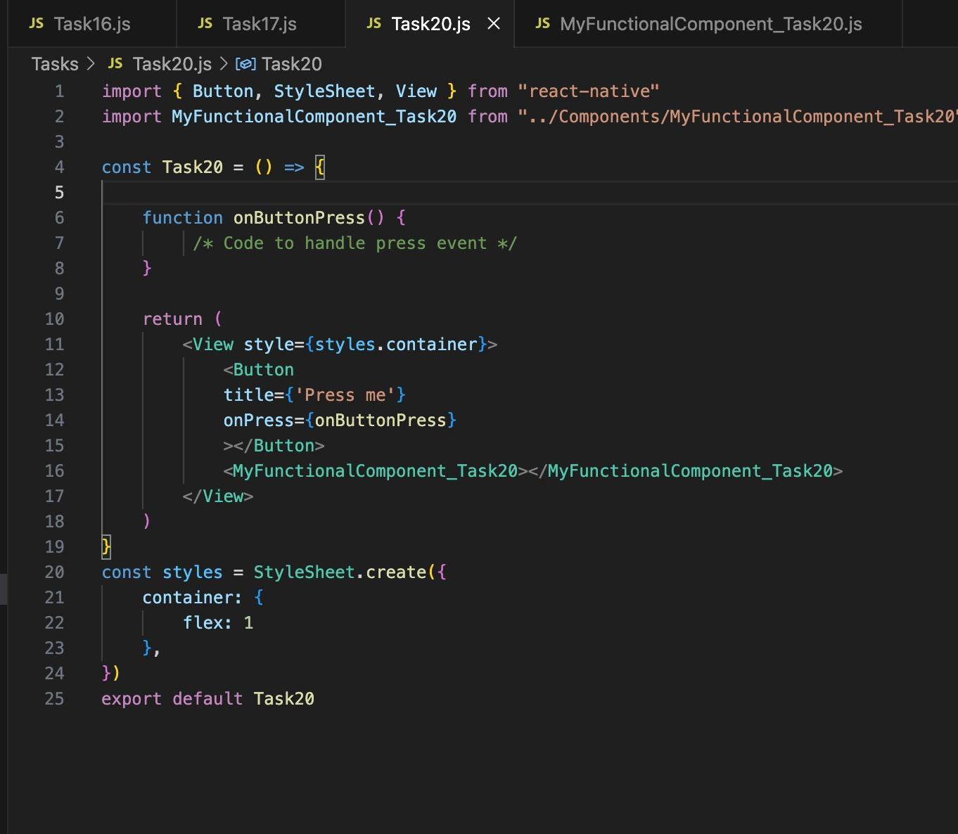
- Using Components in React Native:

Example of a Task Component

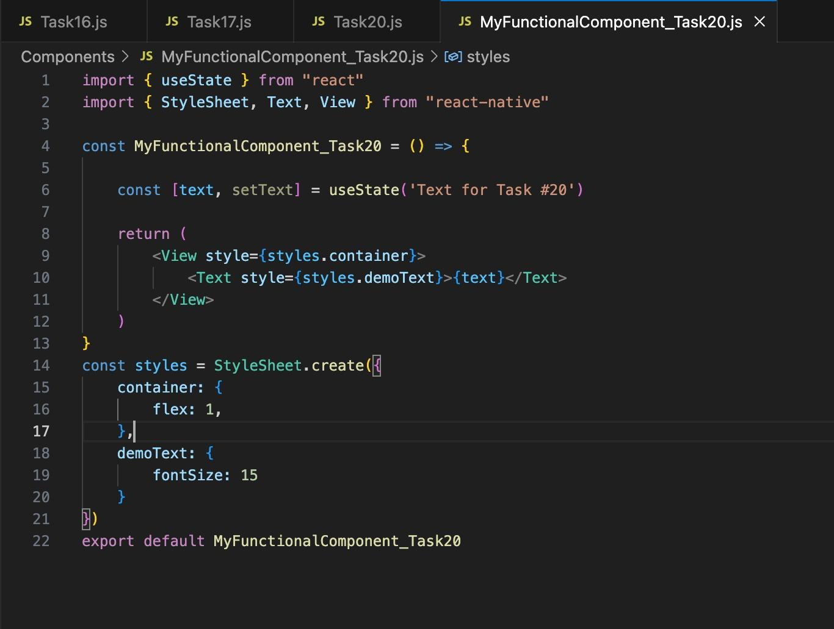

Example of a Nested Component

16. Create a react native app that contains a button with the title "Show" and a hidden text of your name, When the button is pressed it should show your name. If it's pressed again it should hide it and so forth. [react-native, simple conditional rendering]

Resources:
https://reactnative.dev/docs/button
Hide Show View Text Component in React Native on button Click | SKPTRICKS

17. Create a react native app that contains a button with the title "Show" and a hidden text of your name, When the button is pressed it should show your name, and the text of the button should become "Hide", When the button is pressed again it should hide your name and turn the button's text back to "Show". [react-native, simple conditional rendering, simple state management]

18. Create a react native app that when launched shows an activity indicator with the text of "Loading..." for 5 seconds, When it's done the activity indicator and text should disappear and the page should show your name. [react-native, simple state management, Timeouts]

Resources:
https://reactnative.dev/docs/activityindicator
https://www.w3schools.com/js/js_timing.asp

19. Create a react native app that has a button with the title "Show" and a custom class component called MyClassPage. When the button is pressed it should show the MyClassPage component. [react-native, simple state management, class components]
https://www.freecodecamp.org/news/functional-vs-class-components-react-native/

20. Create a react native app that has a button with the title "Show" and a custom class component called MyClassPage. When the button is pressed it should show the MyClassPage component, When MyClassPage becomes visible it should output to the console that it loaded, When MyClassPage is hidden it should output to the console that it unloaded. [react-native, simple state management, class components, class components life cycle]

Resources:
https://www.netguru.com/blog/react-native-lifecycle

21. Create a react native app that has a button with the title "Show" and a custom functional component named MyFunctionPage, And repeat task 20 for MyFunctionPage. [react-native, simple state management, functional components,
functional components life cycle]

Resources:
https://react.dev/reference/react/useEffect
https://reactnative.dev/docs/intro-react?guide=android#custom-components

Hint: The useEffect hook is a function that lets you perform tasks after the component renders. It’s like componentDidMount, componentDidUpdate, and componentWillUnmount combined in class components.

22. Create a react native app that has a text component, and edit MyFunctionPage to include a text input. When the text input of MyFunctionPage is changed it should update the text in the text of the parent component. [react-native,functional components, props]

Hint: You can pass functions or states as props for a component.
Resources:
https://reactnative.dev/docs/props

23. Repeat task 22 for MyClassPage. [react-native, props, class components]
Resources:
https://www.javatpoint.com/react-native-props

24. Create a react native app that has a text input and edit MyFunctionPage to only have a text component instead of a text input, When the text input of the parent components changes, it should update the text in the text component of MyFunctionPage, Don't pass the state of the text as a prop from the parent to the child. [react-native, functional components, forwardRefs, refs]
Resources:
https://react.dev/reference/react/forwardRef
https://react.dev/reference/react/useImperativeHandle
https://medium.com/@nadeem.ahmad.na/understanding-useimperativehandle-a-powerful-hook-for-react-development-46063e44e52a

25. Repeat task 24 for MyClassPage. [react-native, refs, class components]
Hint: Class components have built in reference in react native

26. Create a react native app that has two buttons and a text component. The first button should make a non-blocking request to https://api.ipify.org/ to get the user's IP and display it in the text component, The second button should do the same but it should block the UI while doing so. [react-native, functional components, async/await, promises]

Resources
https://www.smashingmagazine.com/2020/11/comparison-async-await-versus-then-catch/

27. Create a react native app that displays 3 images of your choosing, and a button that chooses what image to display. When pressing the button, display an alert dialog that asks the user to pick the number of one of the images, 1, 2 or 3. The image component should update to reflect the new image that was selected. Add the images to your project by creating a Resource folder in your project's root and moving the images there. [react-native, image component, Alert, Require]

Resources:
https://reactnative.dev/docs/image
https://reactnative.dev/docs/alert

28. Create a react native app that displays a horizontal list of images of your choosing[Choose 10 images minimum]. When the user clicks on an image it should display an alert that says "You have selected image :" followed by the index of the image that was pressed. [react-native, Flatlist, Pressable]

Resources:
https://reactnative.dev/docs/flatlist
https://reactnative.dev/docs/pressable

29. To the app of task 28, Add a button that creates an alert that asks the user to input the index of an image, when the user confirms, scroll to the index of the image in the list. [react-native, Flatlist, Alert]

Resources:
https://reactnative.dev/docs/flatlist

30. To the app of task 28 and 29, Add a small icon to the right corner of each image, When pressed it should remove this image from the list. [react-native, Flatlist, Pressable, Alert]

Resources:
https://medium.com/@dev.rajangarg/working-with-state-arrays-in-react-or-react-native-e27785b10b28

31. To the app of task 28, 29 and 30, Add a small icon to the left corner of each image, When pressed it should repeat this image in the list by adding a new element with the same image to the right of it. [react-native, Flatlist, Pressable, KeyExtractors]

Resources:
https://medium.com/@dev.rajangarg/working-with-state-arrays-in-react-or-react-native-e27785b10b28
https://reactnative.dev/docs/flatlist

32. Create a react native app that displays a video of your choosing and add in a poster to the video. [react-native, video component, image component]

Hints: Use one of those two packages:
https://www.npmjs.com/package/react-native-video
https://docs.expo.dev/versions/latest/sdk/av/

33. Create a react native app that displays a video of your choosing and its poster, Disable the video components' native controls prop and add the following action: [react-native, video component, Refs, Media Controls]
-play/pause when the video is pressed in the middle of the screen

Hints: Consult the documentation of the package that you chose in task 32.

34. Create a react native app that displays the time of the device and the date, Instead of handling the logic in your main component, Create a custom hook called useCurrentTime. [react-native, Hooks, Date and time, Intervals, Memory leaks]
*Hint: use clearInterval when the component is unmounted to avoid memory leaks. Optional: Remove clearInterval if you had it and create a button to toggle your time component on and off and toggle it repeatedly to see its effects in action

Resources:
https://billypentester.medium.com/the-ultimate-guide-to-custom-hooks-in-react-native-945b213a946e

35. Create a react native app with the text inputs of titles: Name, Age and country, and a button called submit. When the submit button is pressed, Create an object of the form:
{
"name" : "name-you-entered",
"age : "age-you-entered",
"country" : "country-you-entered",
"timestamp" : "the-date-and-time-of-the-button-press"
}
then save it in the device's local storage(AsyncStorage). When the app is opened again, Check if the local storage contains any previous info and if it does, Read them and display them as an initial text for the text input components if their timestamp is less than one minute old. Your app should handle the cases where such data does not exist, or an error has happened.[react-native, Async storage, object creation, object deconstruction, date methods]

Resources:
https://react-native-async-storage.github.io/async-storage/docs/usage
https://www.freecodecamp.org/news/javascript-date-comparison-how-to-compare-dates-in-js/

36. Create a scroll view with 100 text components, The text components can contain any random text(A random words generator is provided in the hints). [react-native, scroll-view]
*Hint function to generate a random word(Use it repeatedly):

function generateRandomWord(length) {
let result = '';
const characters = 'abcdefghijklmnopqrstuvwxyz';
for (let i = 0; i < length; i++) {
result += characters.charAt(Math.floor(Math.random() * characters.length));
}
return result;
}

Resources:
https://reactnative.dev/docs/scrollview

37. Add an pull-to-refresh functionality to the scroll view from task 36

Resources:
https://reactnative.dev/docs/scrollview

38. Define two components with the following properties:
Component one: A class component that only renders a text component
Component two: A functional component that renders a text input component and a version of component one
In the main component create 4 versions of component two, Should any of the versions of component two's text inputs change, The same text should appear on all versions of component one. you must use a context and a provider [react-native, contexts, providers, state sharing]

Resources:
https://react.dev/learn/passing-data-deeply-with-context

39. Define a component with the following properties:
Component one: function component that contains a text input component, The text's state MUST be located in this component not the main component.
In the main component add a button to hide component one when pressed, Note that the first component must be unmounted completely, When the button is pressed again show component one again with the same text that was in the
component before it was unmounted earlier. You must use redux. [react-native, functional component's redux, state management]

Resources:
https://medium.com/@itservicesindia/how-to-use-redux-in-your-react-native-app-99a18f382cef

40. Repeat task 39 with a class component [react-native, class component's redux, state management]

41. Create a simple bottom navigation stack with 4 screens, Each screen displays a simple text component of the screen's number when opened. [react-native, navigation]

Resources:
https://reactnative.dev/docs/navigation
https://reactnavigation.org/docs/bottom-tab-navigator/

42. Edit your navigation stack from task 41, Add a button to each of the screens that takes you to other pages. i.e. screen one should have 3 buttons, one that takes the user to page 2, another that takes the user to page 3
and so forth. [react-native, navigation, routes]

Resources:
https://reactnative.dev/docs/navigation

Project I: In this project you will work on a navigation stack similar to the one that you created in tasks 41 and 42 and it has two stages[react-native, Camera API, Location API, Sensors API, File System, Navigation, Media Player].

Stage I:
Screen one: Title camera. In the first screen, Render a camera and a button that takes photos with it. When the user takes a picture, display it over the camera and ask the user if they want to save or discard it; If the user chooses to discard it, delete it from the device, otherwise return to camera for the user to take another picture.

Screen two: Title sensors. In the second screen, Show the device's current location; Altitude, Longitude, Latitude and speed. Below them the current device's X,Y and Z orientation. The location's measurements should update every 10 seconds, The orientation measurements should update every 500 Milliseconds.

Screen three: Title gallery. Show a list of all the images captured by this app(That weren't discarded). Add a pull to refresh functionality.

Screen four: Title slideshow. This screen also shows a list of all the images captured by this app, But this time the scrolling should be disabled. Have the app automatically scroll to the next element(And rotate to the first when the last is reached) every one second. Add a button to pause/resume the slideshow; stop the scrolling when it's enabled and resume it when it's disabled.

Make sure every page’s work is aborted when leaving it, i.e. unmount the camera when leaving the Camera page, Stop the location and orientation sensors when leaving the Sensors page.
Create a github repo called JoVision Project I Stage I.

Stage II:
Screen one: Add the following features:
Switch camera button: Switch between the front and back camera.
Switch mode button: Switch between video and photo capture.
Take photo/ Record video button: Either take a single image, Or start recording a video depending on the selected mode. If the camera was recording a video and the button is pressed again, Stop recording it.
Name each captured image in the following matter:
YourName_CurrentDateAsISOString.mp4/jpg

Screen two: Add the following features.
Add an image of your choosing that depicts a car if the speed is more than speed X, A person walking if it's more than Y but less than X and a person sitting if it's less than Y. Add an image that depicts that orientation of the device; Portrait, Right landscape, Upside down and Left portrait. Update the image every time the sensors make a new reading, Calculating the device's orientation from the sensor data is optional, You may use a community package to do this for you instead.
Note: The image of cars, people etc can be icons instead of images.
Screen three: Title gallery: Show a list of all the images and videos captured by this app, With a pull to refresh functionality, When an image or a video is pressed offer the following operations:
Rename: Rename the selected image to a name of your choice
Delete: Delete the selected image from the device
FullScreen: Send in the selected media to screen 4 and navigate to it

Screen four: Media viewer, It should be hidden from the bottom tab navigator and only accessible through screen three
- If the selected media is a video, Play the video and add in the following features:
  - Play/Pause the video
  - 5 seconds forward
  - 5 seconds rewind
  - Next/Previous media file(Could be an image or a video).

- If the selected media is a picture, Show the image and add in the following features:
- Next/Previous media file(Could be an image or a video).

Hints use the following packages, Note that you don't need to use all of them as two options for the same native API are provided.
https://github.com/mrousavy/react-native-vision-camera
https://docs.expo.dev/versions/latest/sdk/camera/
https://www.npmjs.com/package/react-native-fs
https://docs.expo.dev/versions/latest/sdk/filesystem/
https://www.npmjs.com/package/react-native-location
https://docs.expo.dev/versions/latest/sdk/location/
https://www.npmjs.com/package/react-native-sensors
https://docs.expo.dev/versions/latest/sdk/sensors/

Backend Tasks
Setup:
- Install Visual Studio 2022 Community edition
- In the Workloads tab select ASP.NET and web development option. Then click install
- In the welcome screen choose Create a new project.Choose the ASP.NET Core Web API. Then hit Next.
- Leave everything as default. Then click create.

43. Create a new git repo called JoVision Backend tasks and push your code on it from now on.

44. Create a C# ASP.NET web api with Controller named Greeter, It should accept a name in the query parameter of the URL in following form in GET requests:
yourURL?name=”name-here”
And return “Hello ” followed by the given name. If no name is given the API should return Hello anonymous. [ASP.NET, Query parameters, GET, Controllers]

Resources:
Tutorial: Create a web API with ASP.NET Core | Microsoft Learn

45. Create a C# ASP.NET web API with multiple controllers, the first controller called Greeter should behave in the same way as the API in task 44, While the other controller called BirthDate should accept a name and birthdate in years, months and days in the following form in GET requests:
yourURL?name=”name-here”&years=x&months=y&days=z.
It should calculate the age from the provided years, months and days,
And return “Hello {name}, your age is {the-calculated-age-in-years}”.
If the name is missing it should replace anonymous as the name, If the birth dates are missing it should return “Hello {name}, I can’t calculate your age without knowing your birthdate!”.[ASP.NET, GET, Query parameters, DateTIme, Controllers]

Resources:
https://learn.microsoft.com/en-us/dotnet/api/system.datetime
https://learn.microsoft.com/en-us/dotnet/api/system.datetime.parse

46. Repeat task 45 but instead of the data being sent in the query parameters, it should be sent as a FormData in the body of the request. [ASP.NET, POST, FormData, DateTIme, Controllers]

Resources:
https://learn.microsoft.com/en-us/aspnet/core/mvc/models/model-binding

47. Create a C# ASP.NET web API with the following controllers:
Create: Accepts post requests containing FormData that contain an image in jpg format and a string Owner that contains the name of the owner of the file. It shouldn’t overwrite existing files with the same name. It should return a response of Created, BadRequest or internal server error depending on the outcome.
You should upload the image itself, and a json containing its metadata like its owner, the creation time and last modification time.
Delete: Accepts get requests containing strings in the query parameters: FileName and FileOwner, If the file exists and the owner’s name is the same as the one sent in the request, delete it. It should return a response of Deleted, Forbidden, BadRequest or internal server error depending on the outcome
You should delete the image and its json metadata.
[ASP.NET, Response Codes, File System]

Resources:
https://code-maze.com/csharp-read-and-process-json-file/
https://learn.microsoft.com/en-us/dotnet/api/system.io.filestream
https://mycsharpdeveloper.wordpress.com/2023/07/03/how-to-upload-files-in-asp-net-core-webapi-using-csharp-and-change-file-size-limit/

48. To the API of task 47 add the following controllers in a separate branch:
Update: Accepts post requests containing FormData that contains an image in jpg format and a string Owner that contains the name of the owner of the file, If the file’s name already exists and only if the owner’s name is the same, Update the image with the new one contained in the request. Note that Update can’t be used to create new images like the Create controller. It should return a response of Ok, Forbidden, BadRequest or internal server error depending on the outcome.
You should also update the image’s metadata, i.e. the last modification time.

Retrieve: Accepts get requests containing strings in the query parameters: FIleName and FIleOwner, IF the file exists and the owner’s name is the same as the one sent in the request return the file in the response. It should return an Ok response with the requested file in the body, Forbidden,NotFound or internal server error depending on the outcome.
[ASP.NET, Response Codes, File System]

Resources:
https://code-maze.com/aspnetcore-web-api-return-file/

49. To the API of task 48 add the following controllers in a separate branch. Take a branch Task48 as base. (Keep the branches of 48 and 49 separate):
Filter: Accepts post requests containing FormData that contains CreationDate, ModificationDate, Owner and FilterType. CreationDate and ModificationDate are DateTime objects, Owner is a string and FilterType is an enumeration with the following possible values:

-ByModificationDate: Retrieve the Array of JsonData containing the file name and owner name of the files that were modified before ModificationDate.

-ByCreationDateDescending: Retrieve the Array of JsonData containing the file name and owner name of the files that were created after CreationDate.

-ByCreationDateAscending : Retrieve the Array of JsonData containing the file name and owner name of the files that were created after CreationDate.

-ByOwner: Retrieve the Array of JsonData containing the file name and owner name of the files that are owned by Owner.

Depending on the given FilterType. Return an Ok response with the files that the filter applies to, BadRequest if some required data is missing or the FilterType is invalid or internal server error depending on the outcome.

TransferOwnership: Accepts get request with strings OldOwner, NewOwner in the query parameters. Switch the ownership of all the files owned by OldOwner to NewOwner and return a list of the files of NewOwner, including the ones that existed before the request.
It should return an ok response with the file list in the body, BadRequest or internal server error depending on the outcome.
[ASP.NET, Response Codes, File System, Enumeration, ASP.NET, LINQ]

Resources:
https://learn.microsoft.com/en-us/dotnet/csharp/language-reference/builtin-types/enum
Language Integrated Query (LINQ) - C# | Microsoft Learn

AI Tasks

- Write a python code for text extraction from image and run it using cmd user will enter an image and the output is the text inside this image.

Resources: https://pillow.readthedocs.io/en/stable/

- Write a function called color_to_black(img) that converts an image manually to a grayscale image (without using ready functions from image processing libraries).

Resources: https://pillow.readthedocs.io/en/stable/

- Write a python program that looks at the provided images, and detects which fingers are holding the object, if the finger has pressure, give it a value of 1, if not give it a value of 0 (calculate a threshold to detect whether the value represents pressure or not, the brighter the area the more pressure there is), save the data for each finger on each hand in an excel sheet (do this with your code not manually)

Note: The right side of the image (in blue), represents the data from the pressure sensors on each finger. Only the right half of the image contains relevant data

Hint: There is a coloured line at the bottom of each image, green means there is pressure on one or more fingers, red means there is not.

Images: https://drive.google.com/file/d/1NgJcK7OSSRGctKhmko-PTdUdfhWDTHZq/view?usp=sharing

- Build a deep learning based model that detects chess pieces

Use the following classes to label the data: 'pawn', 'knight', 'bishop', 'rook', 'queen', 'king'

Note: We recommend you use the YOLOv5 algorithm

Data:
https://drive.google.com/file/d/1JllrdfwzFsPTuaI9cE6vMN9GhT6JQYBy/view?usp=drivesdk

- Based on the previous task, when an image from a trained dataset is flipped or rotated and then used to test your model, the model fails to predict it correctly. This issue, known as overfitting, occurs because your model did not train on a sufficiently diverse dataset. 'Data Augmentation' is a technique used to address this problem by creating variations of the training data. By flipping, cropping, blurring, and altering other aspects of the images, you can generate additional data. This expanded dataset, which includes both the original and augmented images, helps your model learn more effectively.
For this task, use the chess dataset you have, augment it, and re-train your model on the new augmented dataset. Then, compare the accuracy of the new results with the previous ones.

- This task is focused on classification, using the labelled data provided, train a classification model, then use the random images to test your model.

Labelled Data: https://drive.google.com/file/d/1AWCbC8LOAGo5Mltyd1gmlPr8vlk5fXl9/view?usp=drivesdk

Random Data: https://drive.google.com/file/d/1yS1vPl0Uu2EMocKbwLI3fiNWhwjhDh0Y/view?usp=drivesdk

